1. Which are the top three variables in your model which contribute most towards the probability of a lead getting converted?

Answer:

Top 3 features/dummy variables that contribute towards lead conversion(Hot leads) in this model are:

* Lead Origin
* Tags
* Total time Spent on Website

Top predictors of the model are shown below.

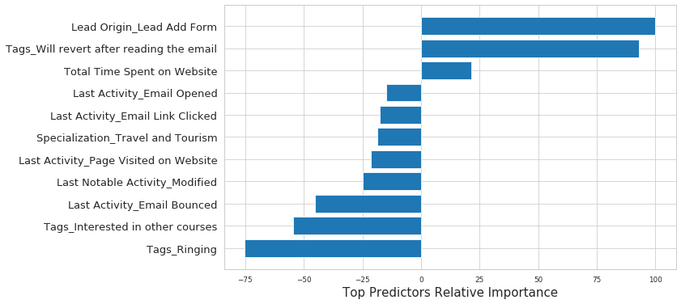

**Fig 1**

1. What are the top 3 categorical/dummy variables in the model which should be focused the most on in order to increase the probability of lead conversion?

Answer:

Based on Fig 1, Top 3 categorical variables in this model, that should be focused are:

* Lead Origin_Lead Add Form
* Tags_Will revert after reading the email
* Last Activity_Email Opened

1. X Education has a period of 2 months every year during which they hire some interns. The sales team, in particular, has around 10 interns allotted to them. So during this phase, they wish to make the lead conversion more aggressive. So they want almost all of the potential leads (i.e. the customers who have been predicted as 1 by the model) to be converted and hence, want to make phone calls to as many of such people as possible. Suggest a good strategy they should employ at this stage.

**Sensitivity** with respect to our model can be defined as the ratio of total number of actual Conversions correctly predicted to the total no of actual Conversions.

Similarly, **Specificity** can be defined as the ratio of total no of actual non-Conversions correctly predicted to the total number of actual non-Conversions.

For a particular model, as one increases, the other decreases and vice versa.

Different values of the sensitivity and specificity can be achieved for the same model by changing the Conversion Probability cutoff threshold value.

When the probability thresholds are very low, the sensitivity is very high and specificity is very low. Similarly, for larger probability thresholds, the sensitivity values are very low but the specificity values are very high.

High sensitivity implies that our model will correctly identify almost all leads who are likely to Convert. It will do that by overestimating the Conversion likelihood, i.e. it will misclassify some non-Conversion cases as Conversions.

Now, since X Education has more man-power for these 2 months and the company wishes to make the lead conversion more aggressive by wanting almost all of the potential leads, we can **choose a lower threshold value of 0.27 for Conversion Probability**.

This will ensure the Sensitivity rating is very high, which in turn will make sure almost all leads who are likely to Convert are identified correctly and the interns can make phone calls to as many of such people as possible

1. Similarly, at times, the company reaches its target for a quarter before the deadline. During this time, the company wants the sales team to focus on some new work as well. So during this time, the company’s aim is to not make phone calls unless it’s extremely necessary, i.e. they want to minimize the rate of useless phone calls. Suggest a strategy they should employ at this stage.

Following the similar logic and context from the explanation to problem 3, High Specificity implies that our model will correctly identify almost all leads who are not likely to Convert. It will do that at the cost of losing out some low Conversion rate risky leads to the competition, i.e. it will misclassify some Conversion cases as non-Conversions.

Therefore, since X Education has already reached its target for a quarter and doesn’t want to make phone calls unless it’s extremely necessary, i.e. they want to minimize the rate of useless phone calls, we can choose a **higher threshold value of 0.6 or 0.7 for Conversion Probability**.

This will ensure the Specificity rating is very high, which in turn will make sure almost all leads who are on the brink of the probability of getting Converted or not are not selected. As a result the agents won’t have to make unnecessary phone calls and can focus on innovative ideas to increase brand value and trust in the market.

This is a good time to organize client meet and greet activities where existing clients could be facilitated and it can be structured as a workshop where an industry leader could also be invited to encourage the lot. Clients can be requested to bring Friends/Family with them, and this can be leveraged as a cross selling/ up selling activity as well.

In this relatively lean time- resources can also be redeployed in refresh of sales collaterals, brainstorming on the sales targets and challenges for the next quarters.